**Filter Webpart**

**Types of filters**

**Choice Filter:** The choice filter allows you to specify values in the tool pane of the Web Part. Users select one of the values from a drop-down menu that appears on the page.

**SharePoint List Filter** When you configure this filter, you point to a SharePoint list and specify the value of a column, such as title, description, date, or document type. Users can browse to the list and then choose from the type of item you specify.

**Current User Filter** Provides either the current user’s login name or a selected SharePoint profile property

**Query String (URL) Filter**: Passes a fixed value(s) from another source that you configure in the tool pane

**1. Choice Filter WebPart**

**Connect a Choice Filter Web Part to Customers List**

Click on site actions --> More Options --> click on Page on left navigation --> then click on Webpart page.

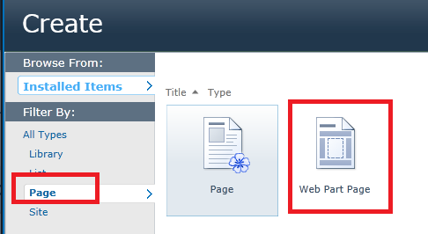

Give Name For WebPart Page And select Layout Template

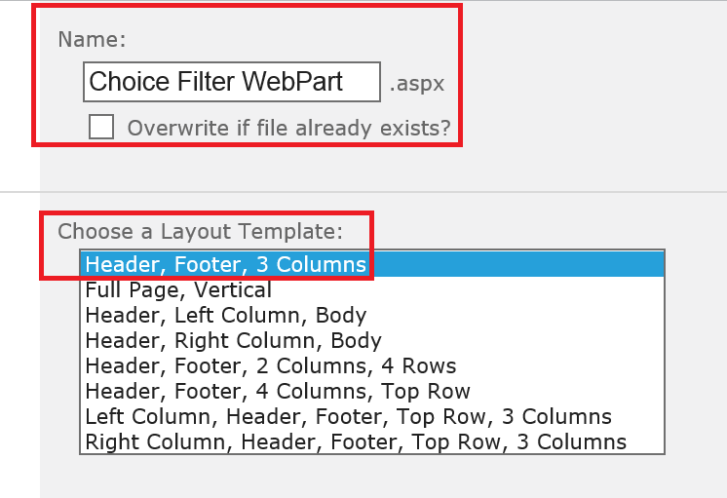

In the Web Part zone that you want to add the Web Part to, click Add a Web Part.

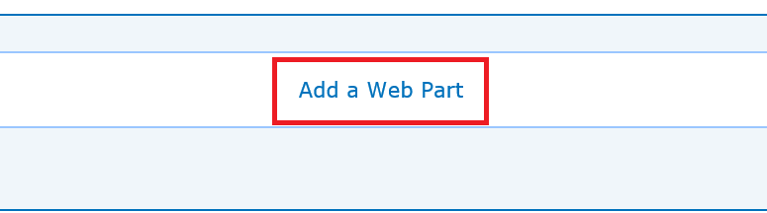

The Add Web Parts dialog box displays. Add the Choice Filter Web Part to the Web Part Page.

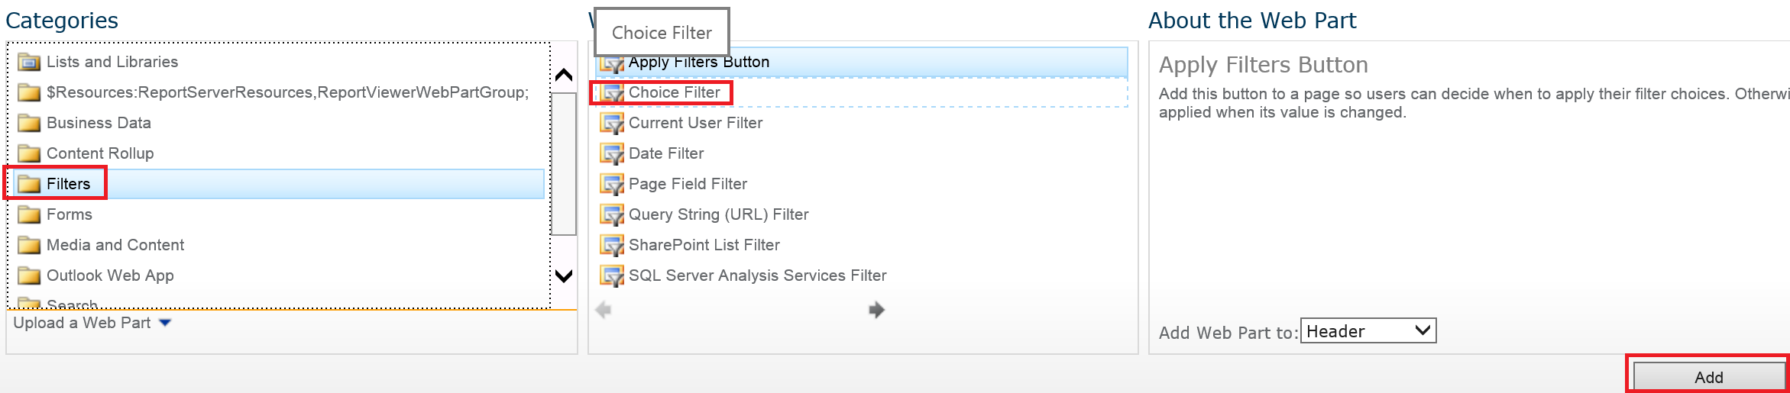

Click Add a Web Part to Customers List

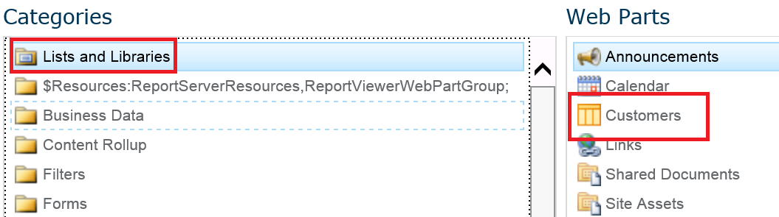

**Customize the Choice Filter Web Part:**

In the Choice Filter Web Part, click the link, Open the tool pane

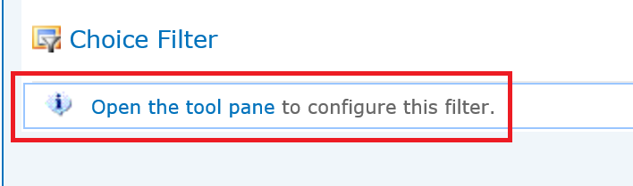

Or click on “Edit Web Part”

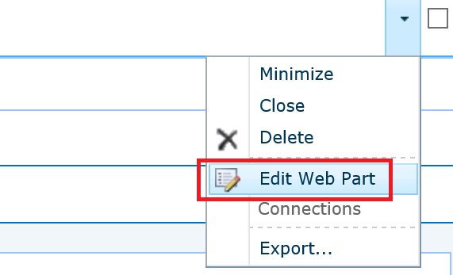

The Choice Filter Web Part enters Edit Mode, and the Web Part tool pane is displayed. - Enter a name in the Filter Name box to identify the Web Part

- Enter the list of values and an optional description

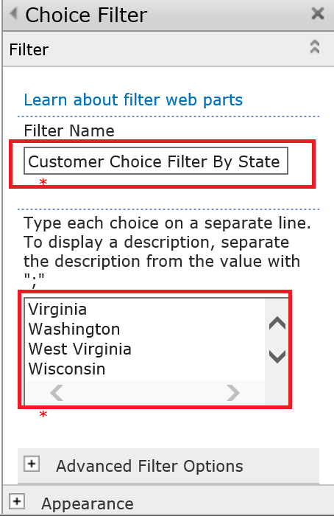

**Optionally, under the Advanced Filter Options**

* In the Control width in pixels. text box, enter a number indicating the width of the choice text box as the number of pixels, or an empty value or "0" to automatically size the Choice Filter Web Part text box.

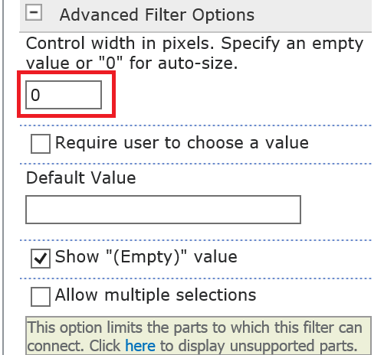

* To display a message that reminds the user to make a choice to filter the data, select the Require user to choose a value check box.

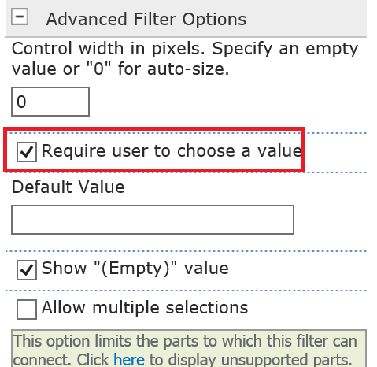 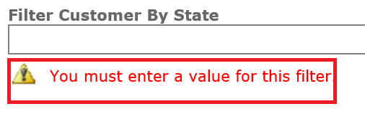

* To enter an initial value in the Choice Filter Web Part text box, enter a default value in the Default Value box,

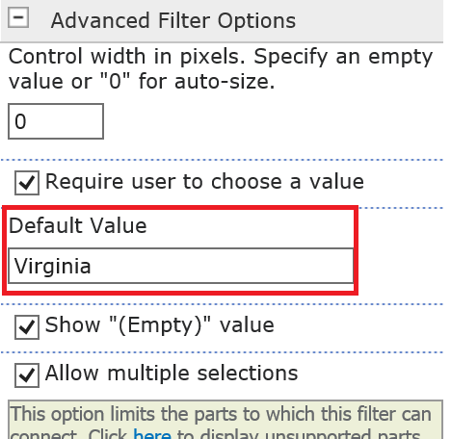

* To enable users to filter by a null value, select "(Empty)" value. For example, users may want to see all customers with no status defined.

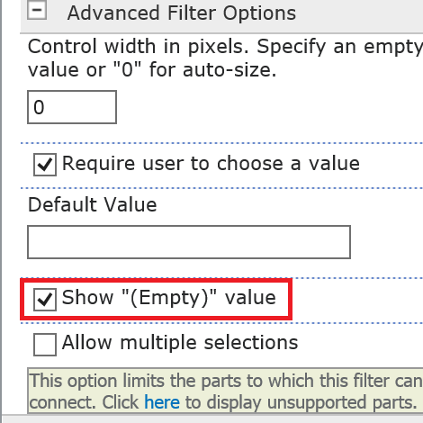 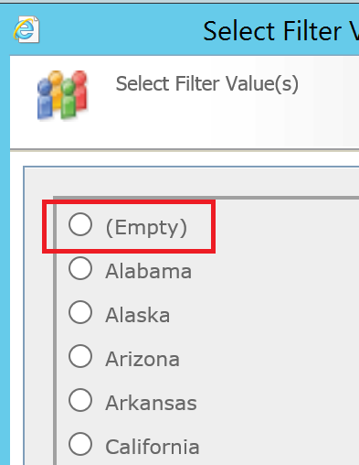

* To enable clearing of a filter so users can see all the values in the Data View Web Part, select Allow Multiple selections

.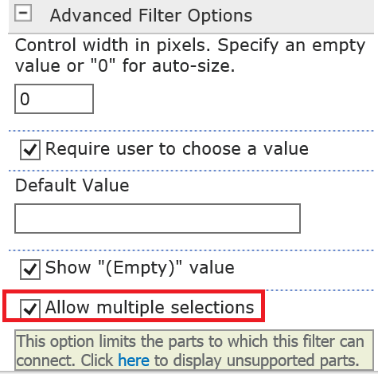 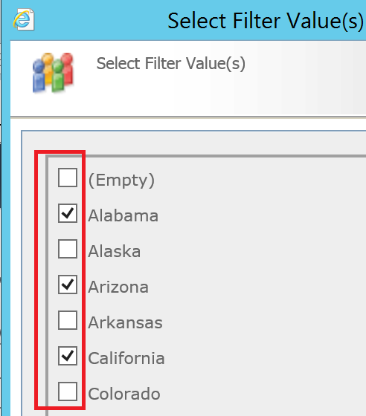

To save the changes, click OK at the bottom of the Web Part tool pane.

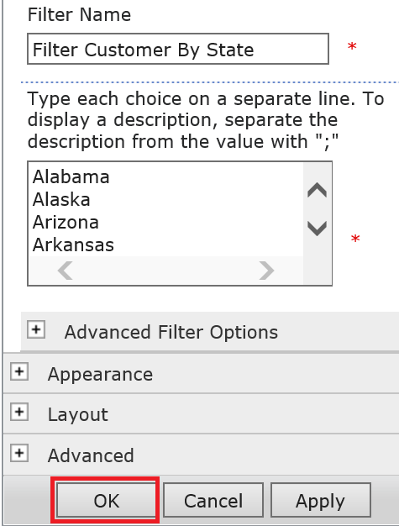

Create Connection Between Choice Filter WebPart and Customers List WebPart

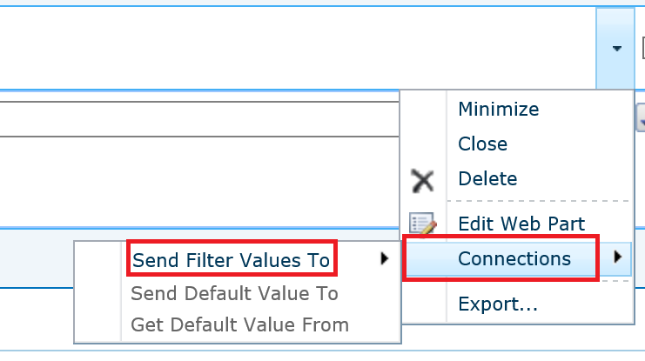

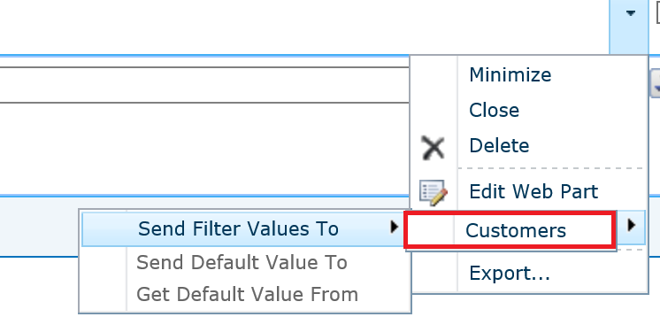

Click Allow Once on a Pop up windows



**Choose Connection**

Connection Type: “Get Filter Values from” then Click Configure

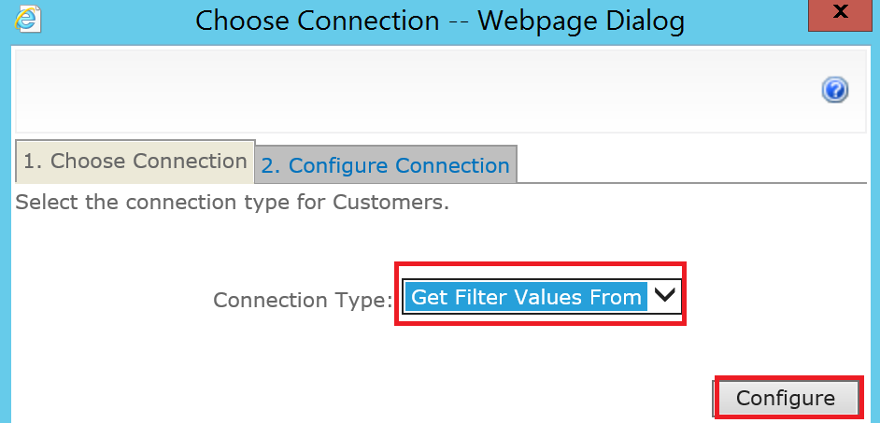

**Configure Connection**

Consumer Field Name: State

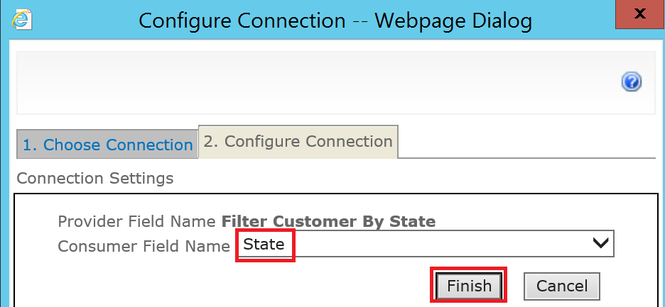

Click Finish

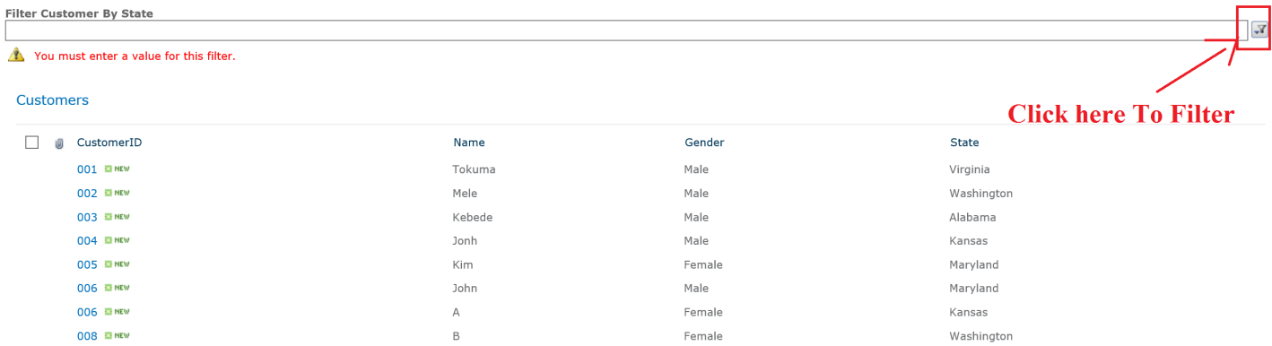

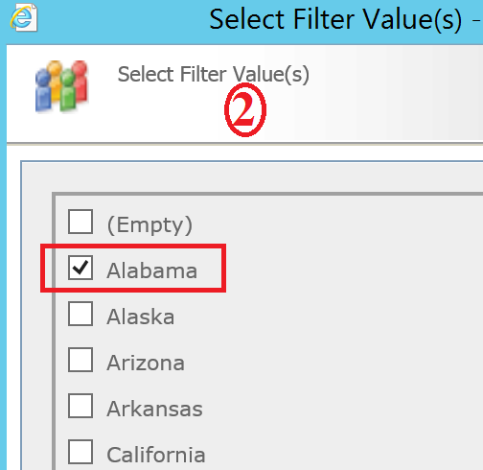

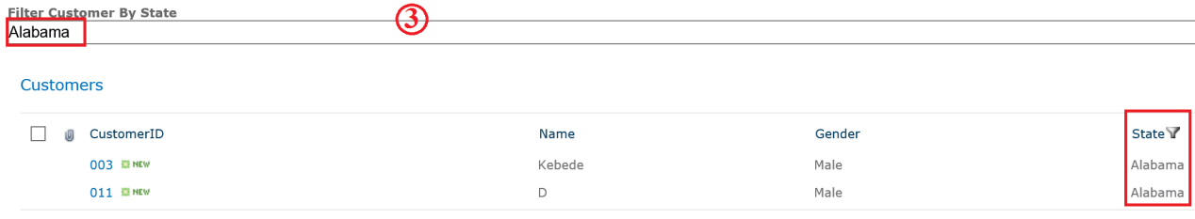

**Connect a Choice Filter Web Part to Two sharepoint List**

Click on site actions --> More Options --> click on Page on left navigation --> then click on Webpart page.



Give Name For WebPart Page And select Layout Template

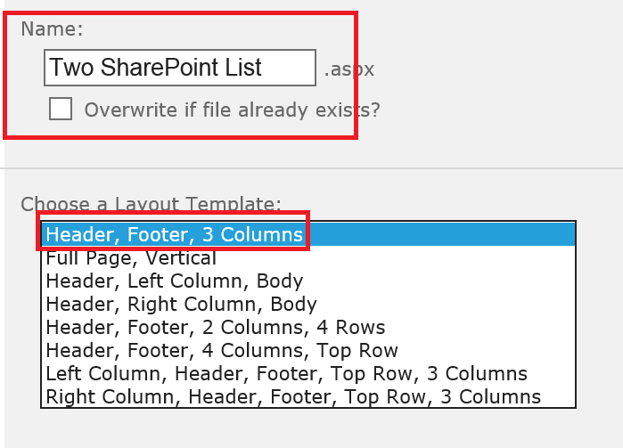

In the Web Part zone that you want to add the Web Part to, click Add a Web Part.



The Add Web Parts dialog box displays. Add the Choice Filter Web Part to the Web Part Page.



Click Add a Web Part to Add Project List and Project Document Library

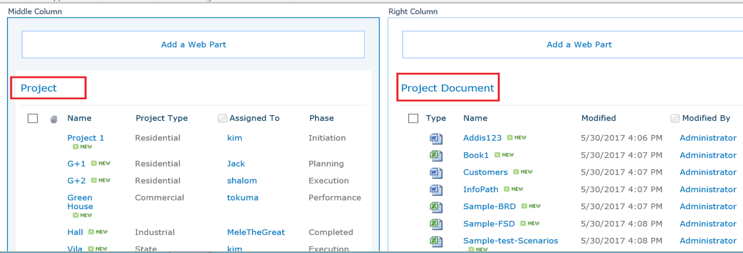

**Customize the Choice Filter Web Part:**

In the Choice Filter Web Part, click the link, Open the tool pane



Or click on “Edit Web Part”



The Choice Filter Web Part enters Edit Mode, and the Web Part tool pane is displayed. - Enter a name in the Filter Name box to identify the Web Part

- Enter the list of values and an optional description

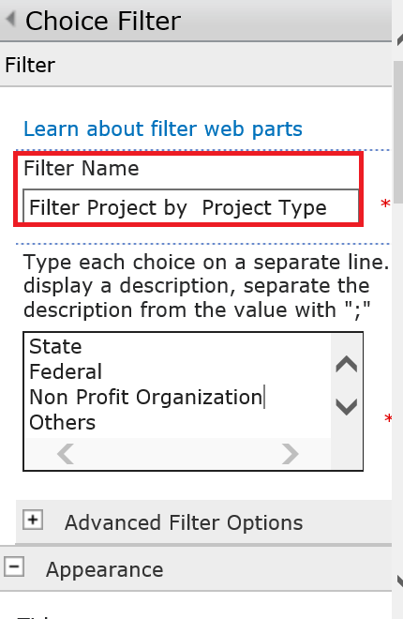

To enable users to filter by a null value, select "(Empty)" value. For example, users may want to see all customers with no status defined.



To save the changes, click OK at the bottom of the Web Part tool pane.

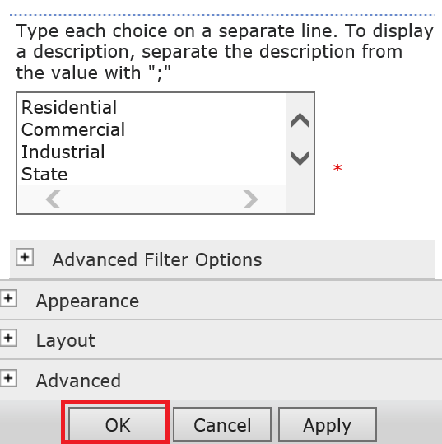

**Create Connection Between Choice Filter WebPart and Project Document Library WebPart**

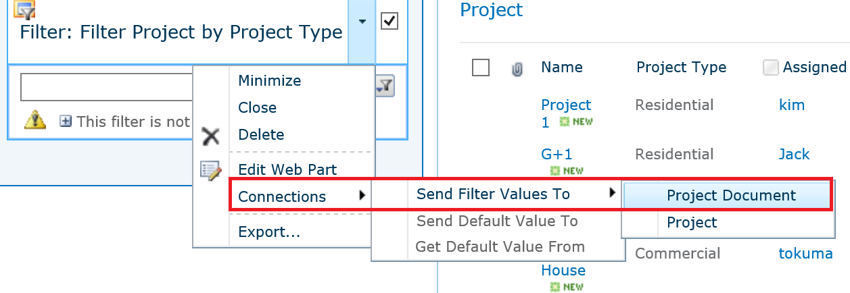

Click Allow Once on a Pop up windows



**Choose Connection**

Connection Type: “**Get Filter Values from**” then Click Configure



**Configure Connection**

Consumer Field Name: Project Type

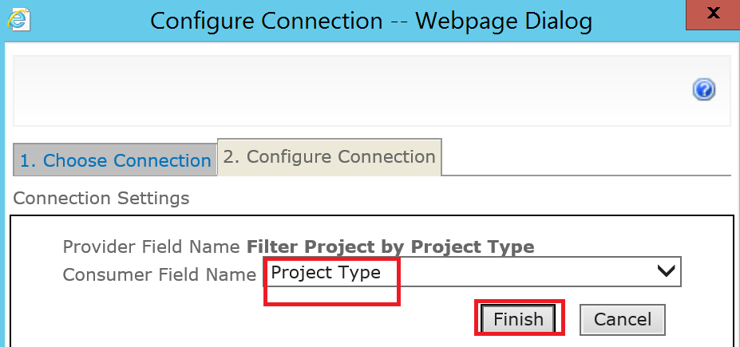

Click Finish

**Agen Create Connection Between Choice Filter WebPart and Project List WebPart**

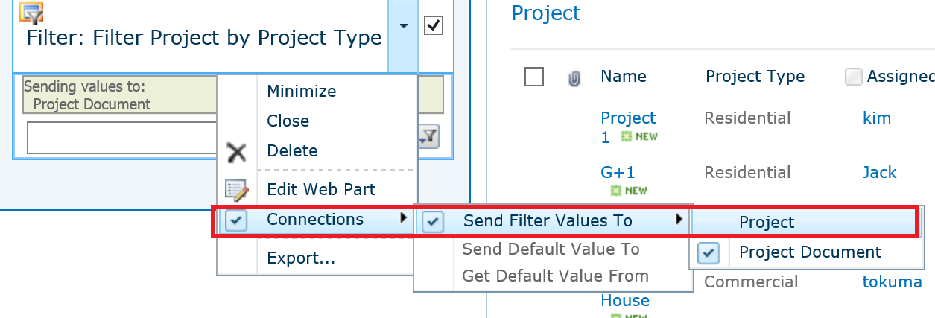

Click Allow Once on a Pop up windows



**Choose Connection**

Connection Type: “**Get Filter Values from**” then Click Configure



**Configure Connection**

Consumer Field Name: Project Type

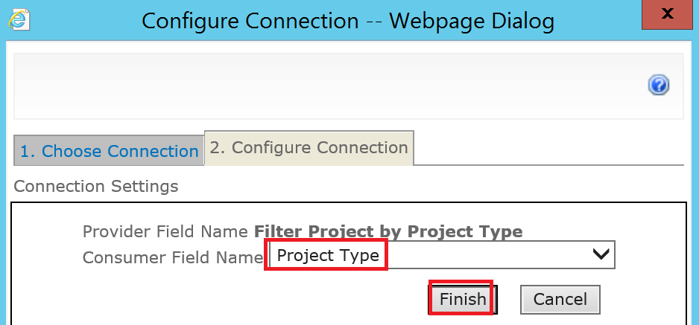

Click Finish

Now Click on Stop Editing and Check the Result

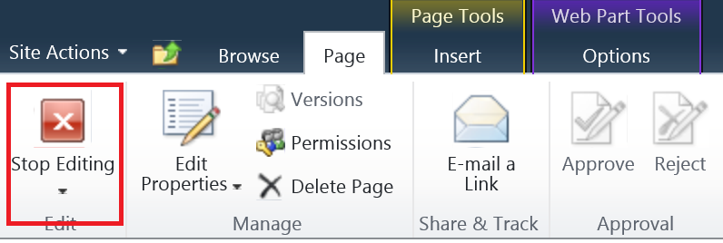

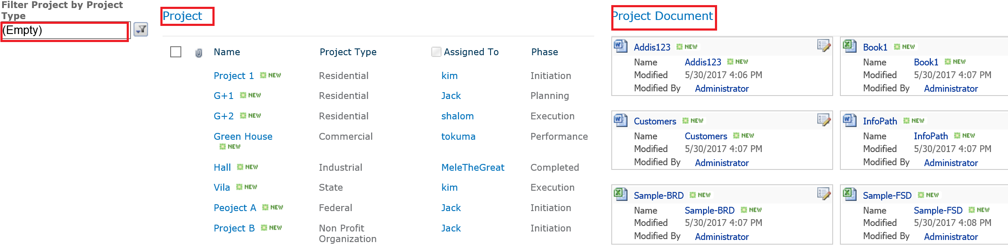

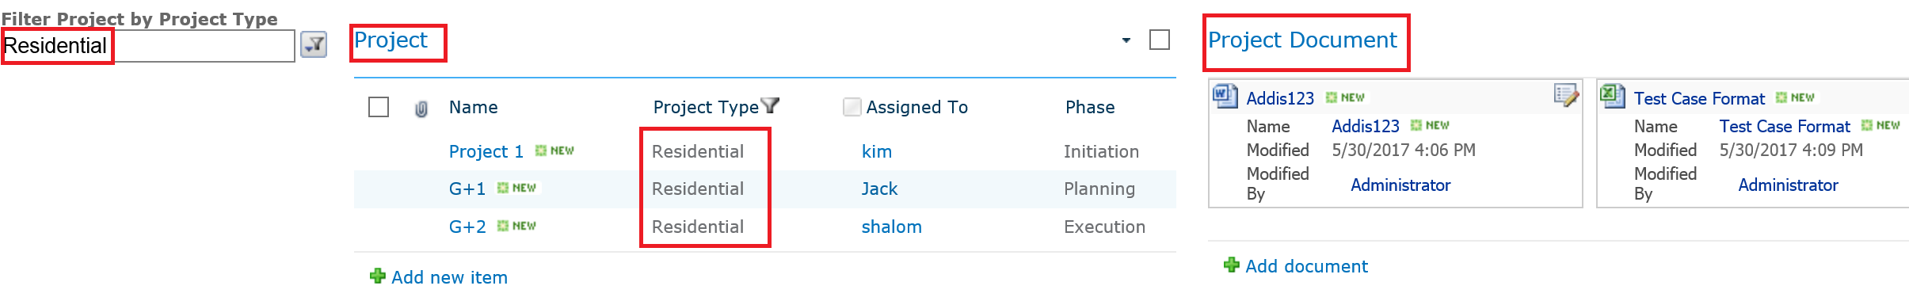

**2. Current User Filter**

* Create a Web Part Page, on the Site Actions menu , More Options, Click on page and then click Web Part Page. Give Name for Web Part Page and select a Template.
* In the Web Part zone that you want to add the WebPart to, click Add a Web Part.
* The Add Web Parts dialog box displays.
* Add the **Current User Filter** Web Part to the Web Part Page.

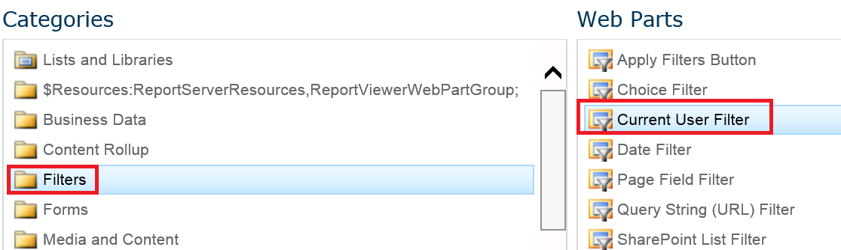

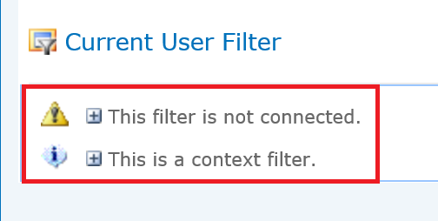

**Again for the Project List**

* In the Web Part zone that you want to add the WebPart to, click Add a Web Part.
* The Add Web Parts dialog box displays.
* Add the **Project** Web Part to the Web Part Page.

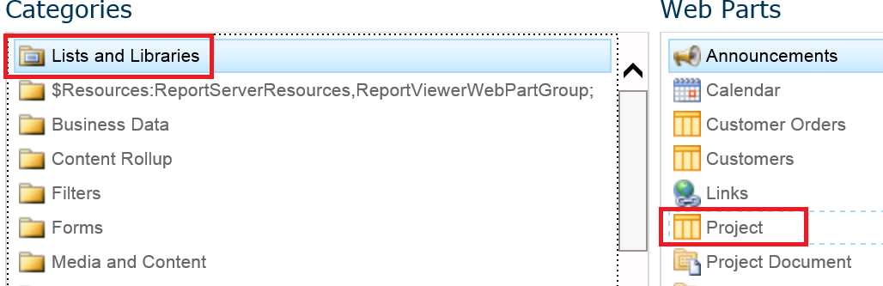

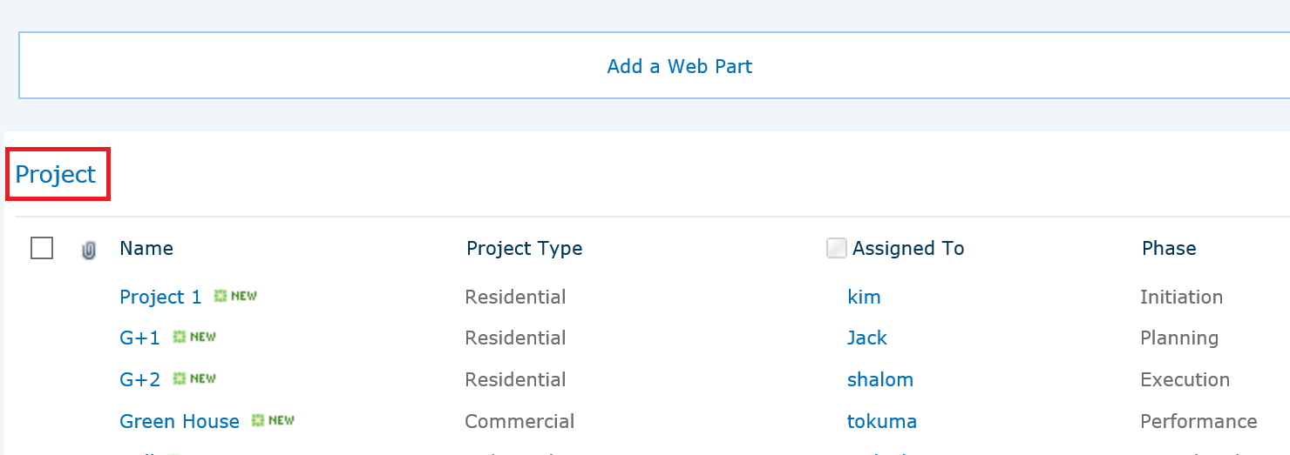

**Customize the Current User Filter Web Part:**

In the Current User Filter Web Part, click on Edit Web Part.

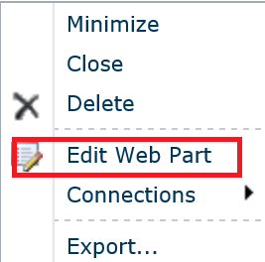

The Current User Filter Web Part enters Edit Mode, and the Web Part tool pane is displayed.

Edit the custom Web Part properties by doing the following:

Enter a name in the Filter Name box to identify the Web Part.

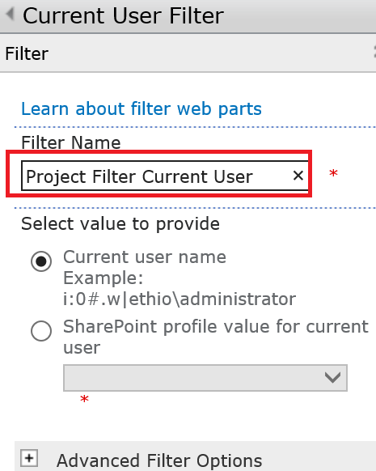

Under the Select value to provide section, do one of the following:

To filter by the user name, select Current user name.

To filter by another value in the current user's SharePoint profile, select SharePoint profile value for current user, and the select an item from the list box.

The list box is populated with the list of all SharePoint profile properties that have a privacy policy of Everyone.

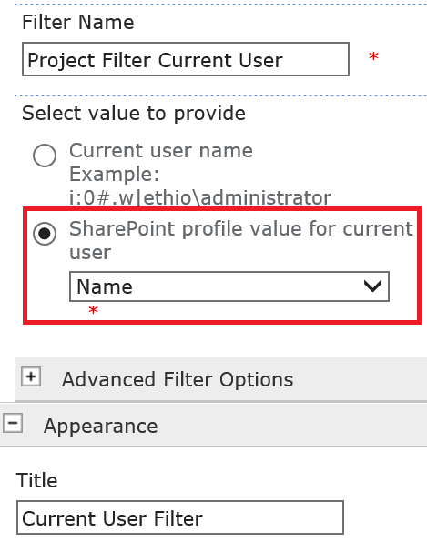

Optionally, under the Advanced Filter Options section, do one or more of the following:

To enable users to filter by a null value, select Send empty if there are no values. For example, you may want to see if a profile value for that user is not entered in the column.

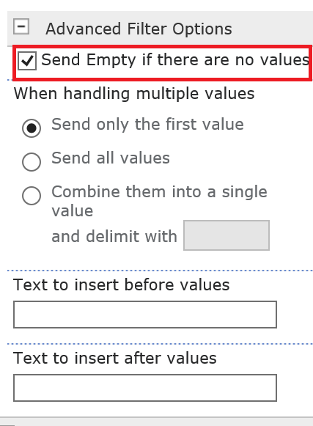

To decide how to handle more than one value, under When handling multiple values, do one of the following:

To pass only one value by using the Web Part connection, select Send only the first value.

To pass two or more values by using the Web Part connection, select Send all values.

To pass two or more delimited values by using the Web Part connection, select Combine them into a single value and delimit with, and then enter one or more characters in the text box.

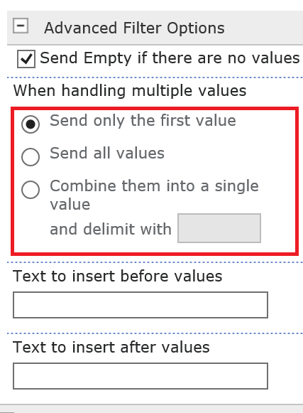

* To prefix a value to the Web Part property value to ensure a match to the column in the SharePoint list, enter text in the Text to insert before values text box. .
* To post-fix a value to the Web Part property value to ensure a match to the column in the SharePoint list, enter text in the Text to insert after values.

To save the changes, click OK at the bottom of the Web Part tool pane.

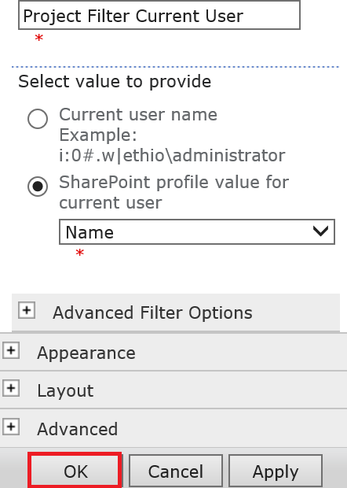

Connect Current User Web Part and Project Web Part

Click on Current User Web Part menu, point to Connections, point to Send Filter Values To, and then click the Project List of the Data View Web Part.

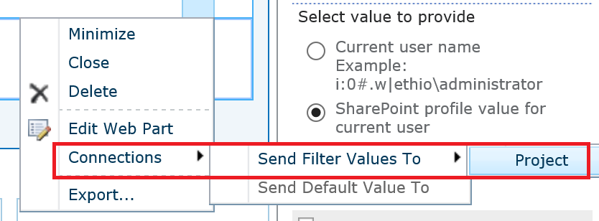

Choose Connection and Click Configure,

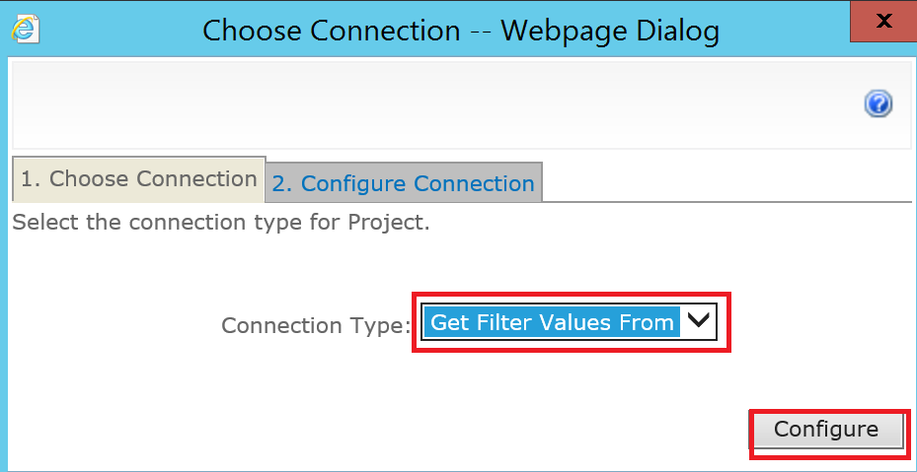

Select the column **Assigned To** to filter in the Data View Web Part from the list box, and then click Finish.

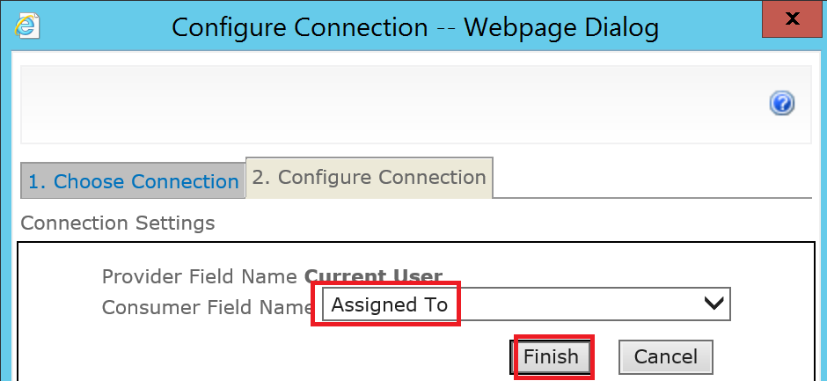

To exit Web Part Page from Edit Mode, Click Stop Editing

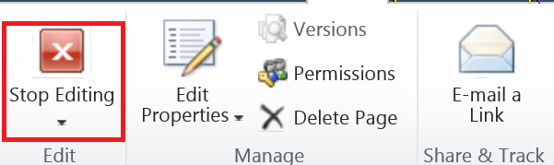

Sign in by Tokuma

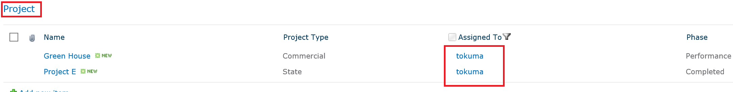

**3. SharePoint List Filter Web Part**

* Create a Web Part Page, on the Site Actions menu , More Options, Click on page and then click Web Part Page. Give Name for Web Part Page and select a Template.
* In the Web Part zone that you want to add the WebPart to, click Add a Web Part.
* The Add Web Parts dialog box displays.

Add the **SharePoint List Filter** Web Part to the Web Part Page.

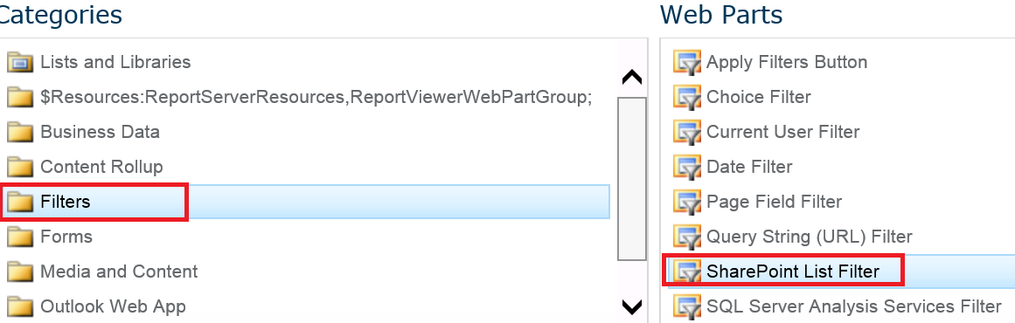

**Again for the Project List**

* In the Web Part zone that you want to add the WebPart to, click Add a Web Part.
* The Add Web Parts dialog box displays.
* Add the **Project** Web Part to the Web Part Page.

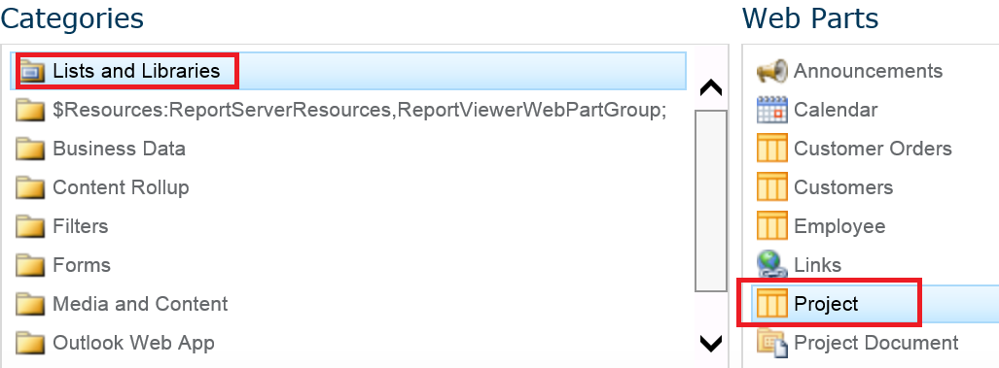

**Customize the SharePoint List Filter Web Part:**

In the SharePoint List Filter Web Part, click the link, Open the tool pane.

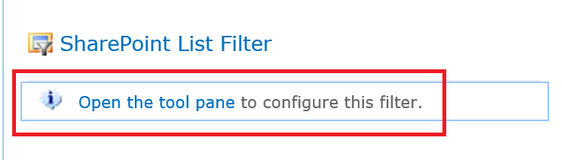

The SharePoint List Filter Web Part enters Edit Mode, and the Web Part tool pane is displayed.

Edit the custom Web Part properties by doing the following:

Enter a name in the Filter Name box to identify the Web Part.

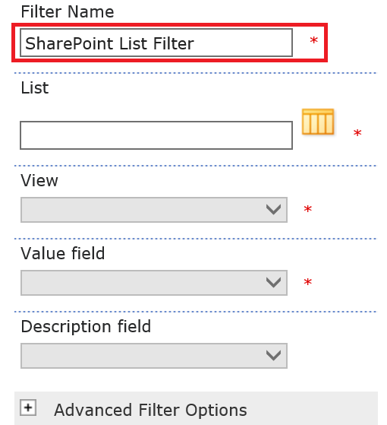

To specify a SharePoint list, enter the URL of a list in the List box, or click Browse next to the text box and search for the list you want.

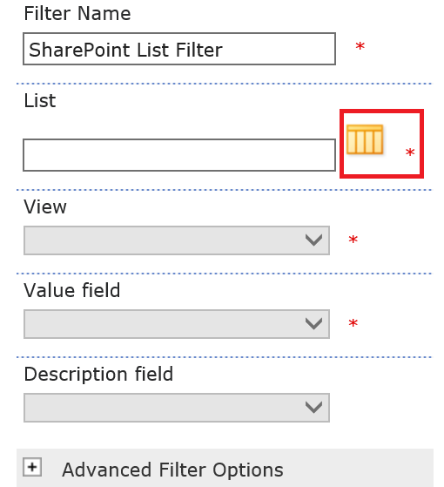

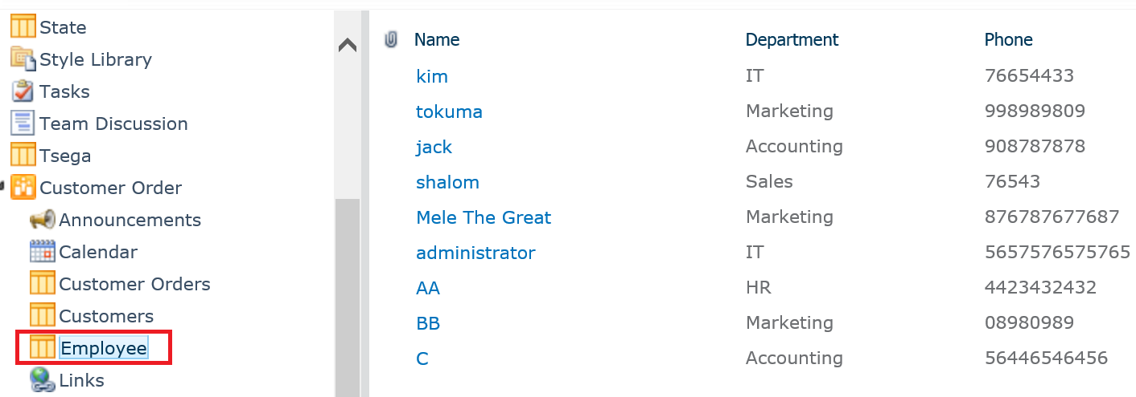

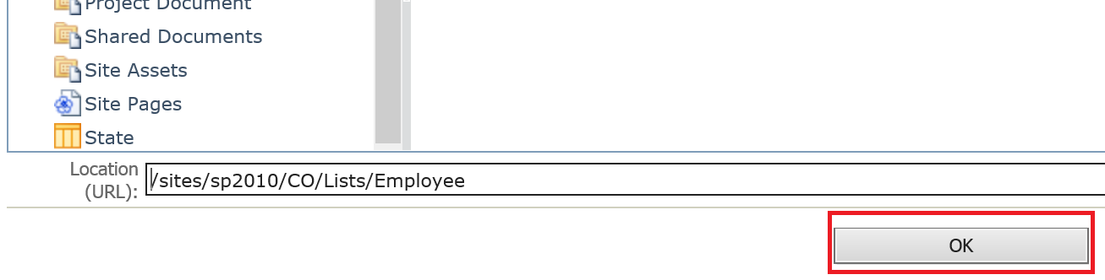

Select a column from the Value field list box. The value column displays all supported columns from the list. Some columns are not supported, such as Title, Calculated, and Multiple lines of text.

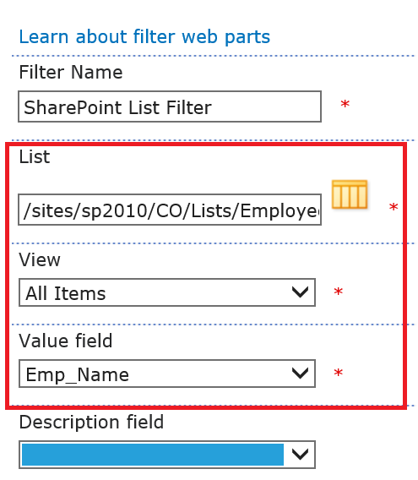

To enable users to filter by a null value, select "(Empty)" value. For example, users may want to see all values in a column that have no entry.

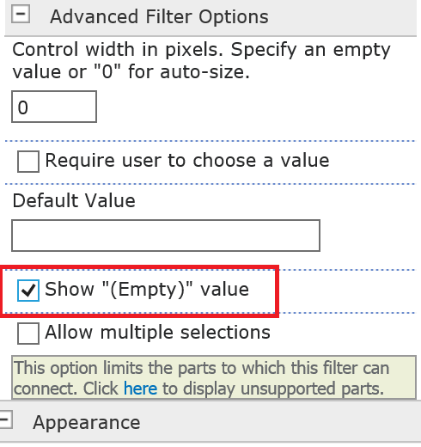

Click ok

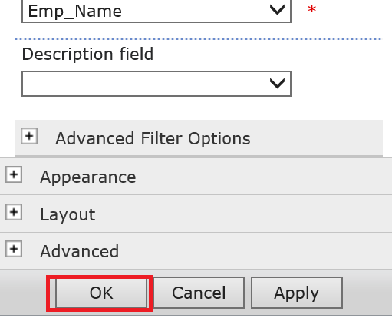

Click on Sharepoint list Web Part menu, point to Connections, point to Send Filter Values To, and then click the Project List of the Data View Web Part.

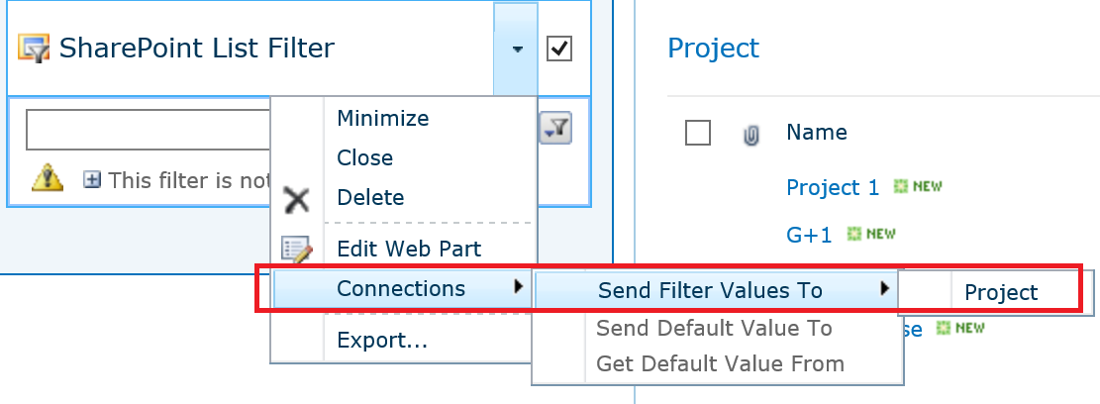

Choose Connection and Click Configure,



Select the column **Assigned To** to filter in the Data View Web Part from the list box, and then click Finish.



To exit Web Part Page from Edit Mode, Click Stop Editing



Result

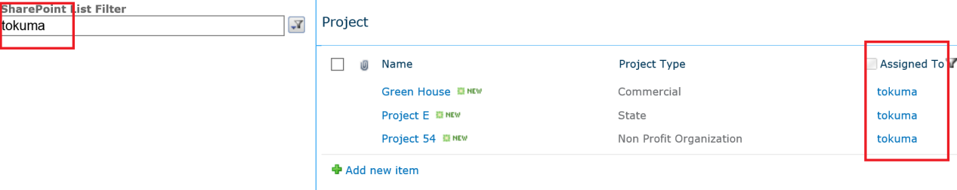

**Query String (URL) Filter Web Part**

Use the Query String (URL) Filter Web Part to click a link that displays a Web Part Page and that automatically filters other Web Parts on that page. For example, you can create a Web Part Page that displays a different set of Documents in Department(IT, Sales, Marketing,Accounting, HR and All).

**Example**

[http://sp2013/sites/sp2010/CO/SiteAssets/QueryString.aspx](http://sp2013/sites/sp2010/CO/SiteAssets/QueryString.aspx?Department=IT)**[?Department=IT](http://sp2013/sites/sp2010/CO/SiteAssets/QueryString.aspx?Department=IT)**

* Create a Web Part Page, on the Site Actions menu , More Options, Click on page and then click Web Part Page. Give Name for Web Part Page and select a Template.
* In the Web Part zone that you want to add the WebPart to, click Add a Web Part.
* The Add Web Parts dialog box displays.
* Add the **Project Document** Web Part to the Web Part Page.

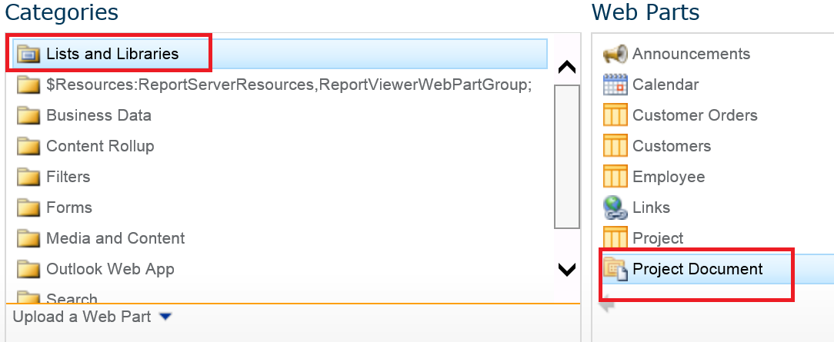

* Again In the Web Part zone that you want to add the WebPart to, click Add a Web Part.
* The Add Web Parts dialog box displays.
* Add the **Query String** Web Part to the Web Part Page.

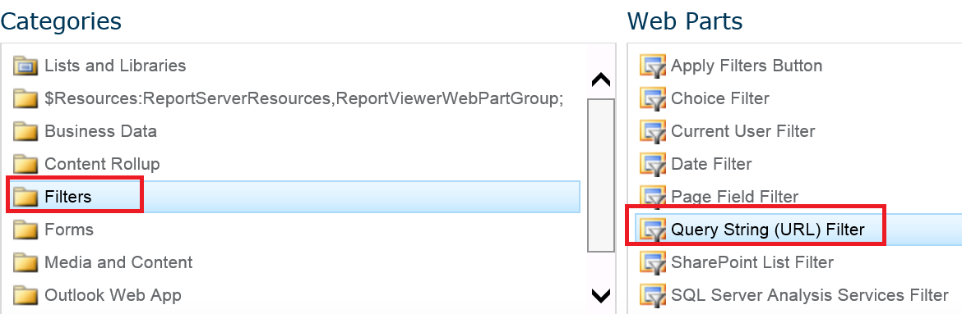

**Then Customize the Query String (URL) Filter Web Part:**

In the Query String (URL) Filter Web Part, click the Open the tool pane link.

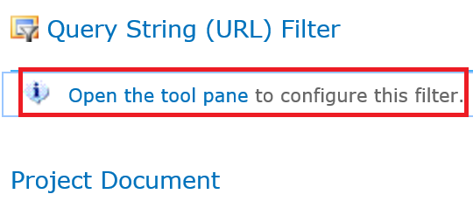

The Query String (URL) Filter Web Part enters Edit Mode, and the Web Part tool pane appears.

Enter a name in the Filter Name box to identify the Web Part.

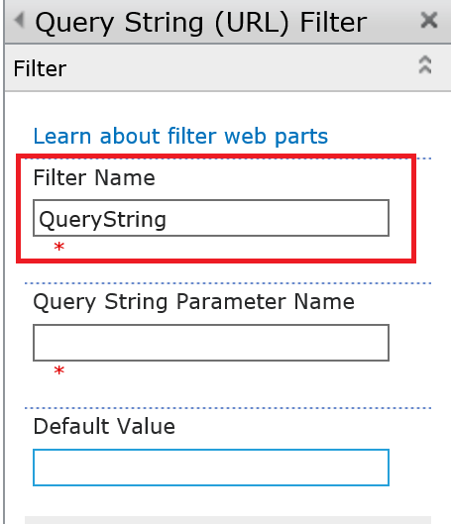

Enter a name in the Query String Parameter Name text box. This name must exactly match the name you define in the URL query string.

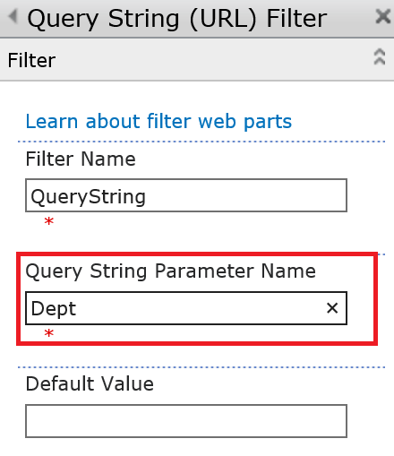

To Save, click OK at the bottom of the Web Part tool pane.

**Create Connection between the two Web Parts**

Click the Web Part menu for the Query String (URL) Filter Web Part, point to Connections, point to Send Filter Values From, and then click Project Document Web Part.

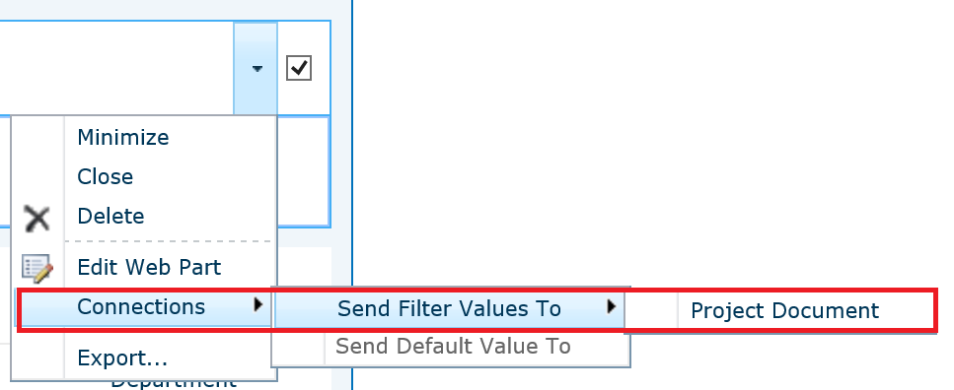

Chooce the Connection Type and Click Configure.

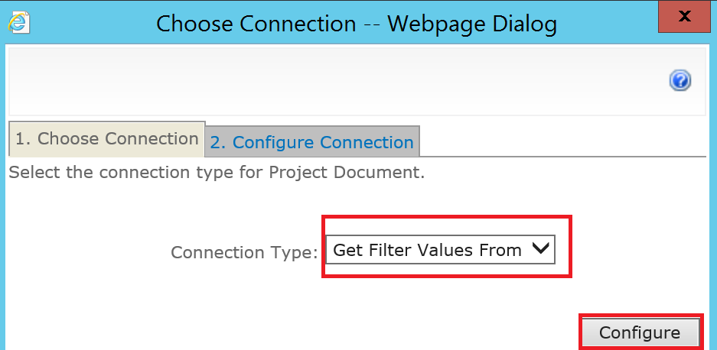

Select Consumer field Name “Department” that you want to filter in the other Web Part from the list box, and then click Finish.

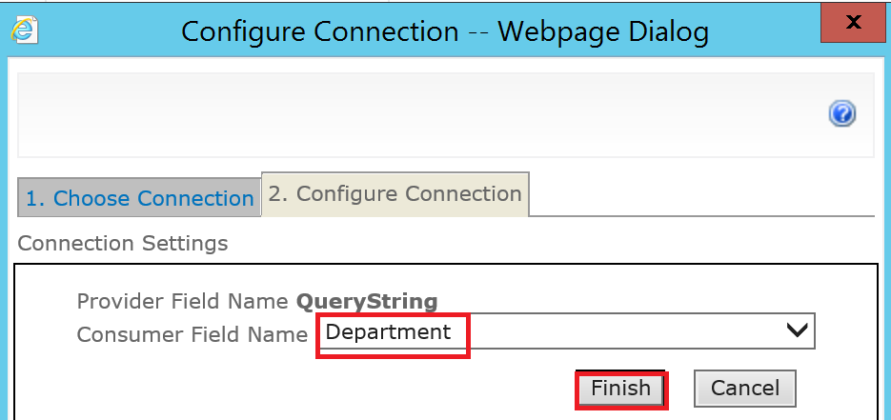

On a Web page, create a link to the Web Part Page and add the query string parameter.

(if Sharepoint 2013 use Promoted Link)

<http://sp2013/sites/sp2010/CO/SiteAssets/QueryString.aspx?>Dept=IT

<http://sp2013/sites/sp2010/CO/SiteAssets/QueryString.aspx?>Dept=HR

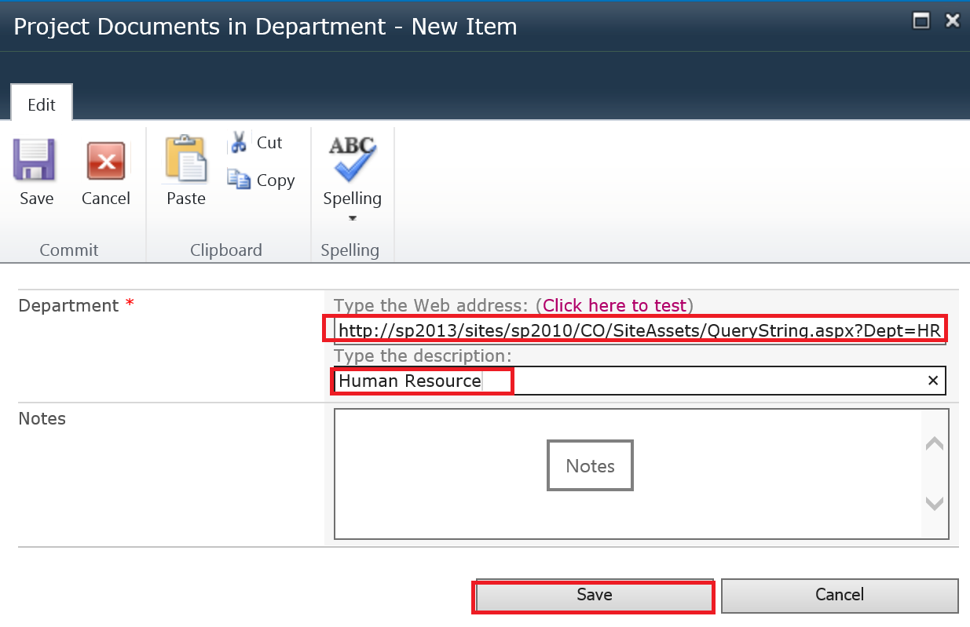

<http://sp2013/sites/sp2010/CO/SiteAssets/QueryString.aspx?>Dept=Sales

<http://sp2013/sites/sp2010/CO/SiteAssets/QueryString.aspx?>Dept=Accounting

<http://sp2013/sites/sp2010/CO/SiteAssets/QueryString.aspx?>Dept=Marketing

